Daily Math Review – The Guide
2nd Grade

The Setting:
- Students are sitting at their desks.
- Students should be assigned a Daily Math Review partner.
- Students should be sitting in close proximity to their partner.
- Students should know what Daily Math Review “TIME” looks and sounds like. It will take some time to establish this routine.

The Materials:
- Students should paper and pencil for DMR.
- You may provide students with whiteboards/manipulatives, if you find them to be necessary and appropriate.
- Use a projector or whiteboard to present the problems.

The Problems:
- The teacher deliberately selects problems that represent different math standards that focus on student review and practice on variations of the same problems throughout a two week period.
- 1 – 3 problems:
  - Start small (1 problem) to establish routine.
  - Add up to 2 more problems as students become comfortable with the process.

The Progression:
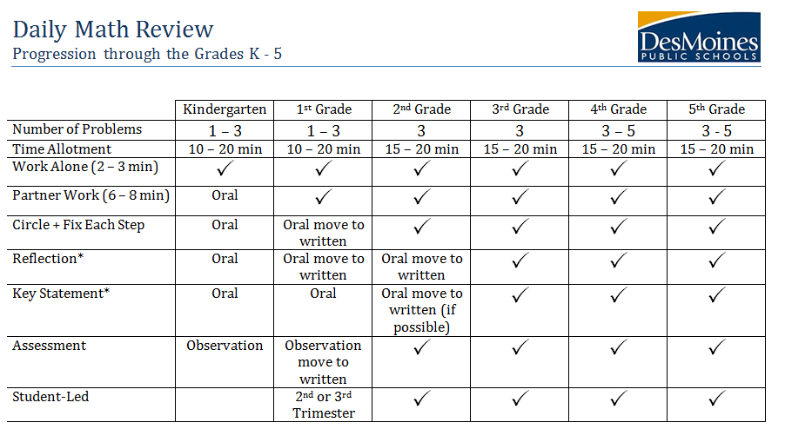

Daily Math Review
Teacher Directed

Page Set Up

Time: 2 – 3 minutes | Purpose: To prepare student’s paper for Daily Math Review.
Teacher Actions –
Follow this Guide:
- Put your name and date in the top right hand corner of your paper.
- Check your partner’s paper.
- Make sure you show all your work.
- Tell your partner to show their work.
- Now let’s say it together: show your work!
----------------------------------------------------------------------------------------------------------------------------------------------
Independent

Time: 2 minutes | Purpose: Students begin to solve problems.
Teacher Actions –
- Walking around
- Monitoring student work
----------------------------------------------------------------------------------------------------------------------------------------------
Partner

Time: 3 - 6 minutes | Purpose: Students collaboratively solve problems.
Teacher Actions –
- Walking around
- Listening to student explanations for the purpose of:
  - Identifying student misconceptions
  - Choosing students who need teacher input
---------------------------------------------------------------------------------------------------------------------------------------------------------------------------
Page Set Up

Time: 5 – 9 minutes | Purpose: Students affirm correct answers. Students find errors. Students reflect on learning.
Teacher Actions –
Follow this guide:
- If you put your name on your paper, put a star by it.
- If you put the date and title on your paper put a star by it.
- Check your partner to see if they put stars on their paper.
  - If you did circle: I am awesome at following directions.
  - If you did not circle: I need to work on following directions.
- Check your partner’s paper to see if they did all those things.
---------------------------------------------------------------------------------------------------------------------------------------------------------------------------
- Star or Circle and Fix each step (for specific feedback).
- State the key statement twice.
  - Students read key statement to their partner.
  - Class recites key statement out loud.
- Reflection:
  - Give students the reflection starters.
  - Have them turn to a partner to complete the sentence they choose:
    - I got this problem correct because I …
    - I got this problem wrong because I …
- Invite a few students to share.
- Repeat for each problem.
- Invite a few students to share.
- Repeat for each problem.

Mrs. Lemke’s Daily Math Review Planning Form

Dates of Cycle: February 11th – February 22nd
Grade: 2nd Grade
Number of Questions: 2
Categories: Addition + Place Value

Monday 2/11  Addition ● ● ● ● ● ● ● ● ● ● ● ● ● 7 + 6 = 10 + ___ 7 + 6 = ___ Place Value What is the value of the underlined digit? 65 | Tuesday 2/12  Addition ● ● ● ● ● ● ● ● ● ● ● ● ● ● ● 9 + 6 = 10 + ___ 9 + 6 = ___ Place Value What is the value of the underlined digit? 55
Wednesday 2/13  Addition ● ● ● ● ● ● ● ● ● ● ● ● ● 6 + 7 = 10 + ___ 6 + 7 = ___ Place Value What is the value of the underlined digit? 34 | Thursday 2/14  Addition ● ● ● ● ● ● ● ● ● ● ● ● ● ● ● ● 8 + 8 = 10 + ___ 8 + 8 = ___ Place Value What is the value of the underlined digit? 21
Friday 2/15  Addition ● ● ● ● ● ● ● ● ● ● ● ● ● ● 6 + 8 = 10 + ___ 6 + 8 = ___ Place Value What is the value of the underlined digit? 83 | Monday 2/18  Addition ● ● ● ● ● ● ● ● ● ● ● ● ● ● ● ● ● ● 9 + 9 = 10 + ___ 9 + 9 = ___ Place Value What is the value of the underlined digit? 55
Tuesday 2/19  Addition ● ● ● ● ● ● ● ● ● ● ● ● 6 + 6 = 10 + ___ 6 + 6 = ___ Place Value What is the value of the underlined digit? 75 | Wednesday 2/20  Addition ● ● ● ● ● ● ● ● ● ● ● ● ● ● 7 + 7 = 10 + ___ 7 + 7 = ___ Place Value What is the value of the underlined digit? 93
Thursday 2/21
Addition  ● ● ● ● ● ● ● ● ● ● ● ● ● ●  8 + 6 = 10 + ___  8 + 6 = ___ | Place Value  What is the value of the underlined digit?  12

Key Statements:  - Addition: Making ten helps me add quickly.  - Place Value: The value of a digit determines its position. | Reflection Starters:  - I got this question correct because…  - I got this problem wrong because…

Friday 2/22
Assessment Day (Every two weeks)
2 categories – 3 questions per category
Addition | Addition  ● ● ● ● ● ● ● ● ● ● ● ●  6 + 6 = 10 + ___  6 + 6 = ___ | Addition  ● ● ● ● ● ● ● ● ● ● ● ● ● ● ●  7 + 8 = 10 + ___  7 + 8 = ___ | Addition  ● ● ● ● ● ● ● ● ● ● ● ● ● ● ●  9 + 6 = 10 + ___  9 + 6 = ___
P.Value | Place Value  What is the value of the underlined digit?  45 | Place Value  What is the value of the underlined digit?  14 | Place Value  What is the value of the underlined digit?  87

Teacher Analysis of the Assessment
- If close to 90% of the class has mastered the category (i.e. Place Value – 10s) you can move on to a new category (i.e. Decomposing Numbers).
- If 90% has not mastered the category (i.e. Place Value – 10s) you will put them in another cycle for two more weeks.
- If after 2 – 3 cycles, 90% of the students still are not mastering the concept, take the category out. This informs the teacher that the category is not review and needs to be taught explicitly.

