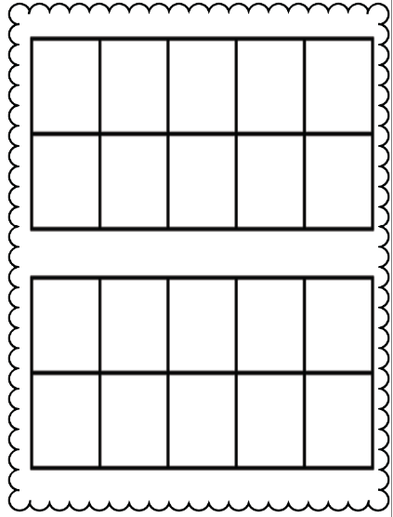

ANSWER:

Put the problem to be solved HERE.

🖍🖍🖍🖍

2 + 3 = 5

Draw a Picture *Use a ten frame* **Write an equation** Part-Part-Whole Box Use counters

**Choose 3 Ways!**