**Daily Math Review – The Guide**

Kindergarten – 1st Grade (Oral)

**The Setting:**

* Students are sitting on the carpet or at their desks.
* Students should be assigned a Daily Math Review partner.
* Students should be sitting in close proximity to their partner.
* Students should know what Daily Math Review “TIME” looks and sounds like. It will take some time to establish this routine.

**The Materials:**

* Students should have manipulatives to work with during Daily Math Review.
* You may provide students with whiteboards if you find them to be necessary and appropriate.
* Use a projector or whiteboard to present the problems.
* The teacher should have a set of manipulatives for modeling.

**The Problems:**

* The teacher deliberately selects problems that represent different math standards that focus on student review and practice on variations of the same problems throughout a two week period.
* 1 – 3 problems:
  + Start small (1 problem) to establish routine.
  + Add up to 2 more problems as students become comfortable with the process.

**The Progression:**

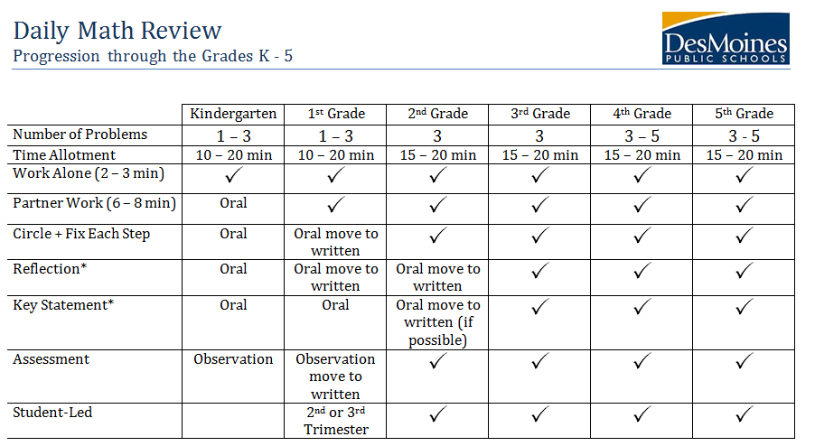

**Kindergarten + First Grade Example**

*----------------------------------------------------------------------------------------------------------------------------------------------*

**Step One: Teacher directs students to the carpet for Daily Math Review time.**

***Teacher:*** *“Boys and Girls, please find your spot on the carpet so we can begin Daily Math Review. On your way to the carpet, please take the bag of the blocks that we will be using for the review today. Once you have found your spot on the carpet, place the bag in front of you and sit quietly with your hands on your head.”*

(Preparation: The teacher must have the manipulatives organized and easy to grab. It is important to the process, that the students understand the expectation when walking, when sitting on the carpet and when working with manipulatives.)

*----------------------------------------------------------------------------------------------------------------------------------------------*

**Step Two: Presenting the first problem.**

***Teacher:*** *“Okay, Kindergarteners, I am going to put up our first problem on the white board. I am going to set the timer for one minute. I want to see you working independently to solve the problem using your manipulatives.”*

How many more to make 5?



(Preparation: The teacher will have the problem already created and ready to present to the students. The problem should be a review concept for the students.)

*----------------------------------------------------------------------------------------------------------------------------------------------*

**Step Three: Students work on the problem independently + then with partners.**

* Give the students 1 – 2 minutes to work on the problem independently. It is important that each student has a chance to do some of their own thinking.
* After independent work time, have students assigned to a partner. The students will discuss the problem with a partner (2 – 3 minutes).
* The teacher should be walking around during this time monitoring student responses.

***Teacher:*** *Now, that we have finished working alone, I want you to turn to your DMR partner and talk about the problem. Today, let’s use the sentence starter: “I got this answer because…”*

(Preparation: Students need to know who their partner is, as well as, how to work well with partners. The teacher may provide the students with a sentence starter to help students discuss the problem. The teacher may want to highlight good examples of partner work for the students.)

*----------------------------------------------------------------------------------------------------------------------------------------------*

**Step Four: Teacher processes the problem.**

* Process the problem chorally with the class.
* Use direct modeling with the manipulatives.

*---------------------------------------------------------------------------------------------------------------------------------------------*

**Step Five: Teacher gives students a reflection for students to echo to their partner.**

* Reflection is given with students echoing in the beginning of the year.
* Once students are used to reflecting – the teacher can use a sentence starter (1st Grade).

***Teacher:*** *Your reflection today is: “I can add two and three to make five.” Say it once with me (Students say it chorally as a class). Now turn to your partner and say it again.*

Preparation: Write the reflection on the board for the students to see. Second semester first graders can use sentence starters:

* I got this problem correct because I …
* I got this problem wrong because I …
* I made a connection with…
* I need to practice…

---------------------------------------------------------------------------------------------------------------------------------------------------------------------------

**Step Six: Students state the key statement multiple times.**

* Teacher posts and states the key statement.
* Teacher has the students repeat the key statement several times.

***Teacher:*** *Our key statement today is: “Five frames help me count.” Say it with me… Say it to your partner…*

*----------------------------------------------------------------------------------------------------------------------------------------------*

* Repeat the process with each problem.
* First grade can move to paper and pencil when ready, but still only doing one problem at a time.

----------------------------------------------------------------------------------------------------------------------------------------------

**Kindergarten + First Grade Cycle**

* A cycle is 9 days of practice and on the 10th day, the teacher will **informally** assess.
* Each question should be from a different category.
* The questions in the cycle from each category should be similar and use the same key statement. See below for examples:

Mrs. Benson’s Daily Math Review Planning Form

**Dates of Cycle:** February 11th – February 22nd

**Grade:** Kindergarten

**Number of Questions:** 2

**Categories:** Five Frames and Composing Numbers

|  |  |  |  |  |  |  |  |  |  |  |  |  |  |  |  |  |  |  |  |  |  |  |  |
| --- | --- | --- | --- | --- | --- | --- | --- | --- | --- | --- | --- | --- | --- | --- | --- | --- | --- | --- | --- | --- | --- | --- | --- |
| Monday 2/11   |  |  |  |  |  |  |  | | --- | --- | --- | --- | --- | --- | --- | | **Five Frames**  How many more to make five?   |  |  |  |  |  | | --- | --- | --- | --- | --- | | ● | ● |  |  |  | | **Composing Numbers**  Make 5  One more than | | Tuesday 2/12   |  |  |  |  |  |  |  | | --- | --- | --- | --- | --- | --- | --- | | **Five Frames**  How many more to make five?   |  |  |  |  |  | | --- | --- | --- | --- | --- | | ● |  |  |  |  | | **Composing Numbers**  Make 2  One more than | | Wednesday 2/13   |  |  |  |  |  |  |  | | --- | --- | --- | --- | --- | --- | --- | | **Five Frames**  How many more to make five?   |  |  |  |  |  | | --- | --- | --- | --- | --- | | ● | ● | ● |  |  | | **Composing Numbers**  Make 3  One more than | |
| Thursday 2/14   |  |  |  |  |  |  |  | | --- | --- | --- | --- | --- | --- | --- | | **Five Frames**  How many more to make five?   |  |  |  |  |  | | --- | --- | --- | --- | --- | | ● | ● | ● | ● |  | | **Composing Numbers**  Make 8  One more than | | Friday 2/15   |  |  |  |  |  |  |  | | --- | --- | --- | --- | --- | --- | --- | | **Five Frames**  How many more to make five?   |  |  |  |  |  | | --- | --- | --- | --- | --- | | ● | ● |  |  |  | | **Composing Numbers**  Make 4  One more than | | Monday 2/18   |  |  |  |  |  |  |  | | --- | --- | --- | --- | --- | --- | --- | | **Five Frames**  How many more to make five?   |  |  |  |  |  | | --- | --- | --- | --- | --- | | ● |  |  |  |  | | **Composing Numbers**  Make 7  One more than | |
| Tuesday 2/19   |  |  |  |  |  |  |  | | --- | --- | --- | --- | --- | --- | --- | | **Five Frames**  How many more to make five?   |  |  |  |  |  | | --- | --- | --- | --- | --- | | ● | ● | ● | ● |  | | **Composing Numbers**  Make 1  One more than | | Wednesday 2/20   |  |  |  |  |  |  |  | | --- | --- | --- | --- | --- | --- | --- | | **Five Frames**  How many more to make five?   |  |  |  |  |  | | --- | --- | --- | --- | --- | | ● | ● | ● |  |  | | **Composing Numbers**  Make 9  One more than | | Thursday 2/21   |  |  |  |  |  |  |  | | --- | --- | --- | --- | --- | --- | --- | | **Five Frames**  How many more to make five?   |  |  |  |  |  | | --- | --- | --- | --- | --- | | ● | ● |  |  |  | | **Composing Numbers**  Make 6  One more than | |
| Friday 2/22  **Assessment Day**  **Informal Assessment: Pose the same type of problems. Observe student progress.**   |  |  |  |  |  |  |  | | --- | --- | --- | --- | --- | --- | --- | | **Five Frames**  How many more to make five?   |  |  |  |  |  | | --- | --- | --- | --- | --- | | ● |  |  |  |  | | **Composing Numbers**  Make 3  One more than | | | |

Key Statements will remain the same each day:

* Five Frames help me count.
* Numbers build by exactly one each time.

The Assessment:

* The assessment will be informal through observation.
* If close to 90% of the class has mastered the category (i.e. five frames) you can move on to a new category (i.e. 10 frames).
* If 90% has not mastered the category (i.e. five frames) you will put them in another cycle for two more weeks.
* If after 2 – 3 cycles, 90% of the students still are not mastering the concept, take the category out. This informs the teacher that the category is not review and needs to be taught explicitly.

*If you are struggling to develop a list of categories – use the list of routines in the resource guide.